PHYS 202 Spring 2020 Test #2 Equations Sheet, You may tear this page.

Heat transfer: $Q=mc∆T$ $Q=mL$ Electric current = I = $\frac{Charge}{Time}$  
  
Ohm’s law: V = IR Electric Power = P = IV Electrical energy =IVt

Resistance in terms of resistivity and dimensions: $R=ρ\frac{L}{A}$

|  |  |  |  |
| --- | --- | --- | --- |
| Electric potential due to a point charge (q) at a distance r: | Electric potential in terms of EPE and point charge (q): | Electric field due to a point charge (q) at a distance r: | Electric field (E) from potential gradient: |
| $$V=k\frac{q}{r}$$ | $$V=\frac{EPE}{q}$$ | $$E=k\frac{q}{r^{2}}$$ | $$\vec{E}=-\frac{∆V}{∆X}$$ |

Capacitors:   

|  |  |  |
| --- | --- | --- |
| Combination | Resistors | Capacitors |
| Series |  |  |
| Parralel |  |  |

PHYS 202 Spring 2020 Test #2 Name:________________________

I. Select the correct answer for the following multiple choice questions and write your answer in the line next to the question number.

____1. Electric current is defined as,  
____2. Electric power is defined as,  
Answers for 1 & 2  
a. Energy flow per unit area b. Charge flow per unit time  
c. Charge flow per unit area d. Charge flow per unit volume  
e. Energy flow per unit time f. Energy flow per unit volume

____3. The *electron-volt* is a unit for  
a. Force b. Charge c. Power d. Energy e. Voltage

4-5) An appliance draws a current of 600 mA when connected to a 120-volt outlet.   
____4. What is the resistance of the appliance in SI unit?  
____5. What is the power of the appliance in SI unit?

Answers for 4 & 5

a. 0.2 b. 5 c. 72 d. 200 e. 2000 f. 72,000

____6. Which one of the following biomedical application deals with the heart?  
a. EKG b. ECG c. EEG d. ERG e. CEG

____7. Estimate the monthly cost of electricity for operating a 950-W electric iron for 5 minutes a day. Assume a cost of 9 cents per kWh.

1. 0.71 cents b. 2.3 cents c. 21 cents d. 51 cents e $ 2.57

____8. In a string of Christmas tree lights, when one of the bulbs is removed, all the bulbs go off. In this string bulbs are connected in:

a. Series b. Parallel  
  
____9. What is the direction of current for the circuit shown?  
a. Clockwise b. Counter clockwise

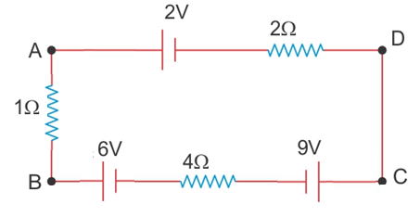

____10. Determine the magnitude of the current for the circuit   
shown?  
a. 0.14 A b. 0.71 A c. 0.83 A   
d. 2.2 A e. 2.4 A

____11. What is the potential difference, VA – VC?  
a. 0.55 volt b. 9.0 volt c. 1.2 volt d. 8.0 volt e. 2.3 volt  
  
____12. A metal wire of length L and cross sectional area A, has a resistance R. What will be the resistance of the same material with twice the length and twice the radius?  
a. 4R b. 2R c. R d. ½ R e. ¼ R

II. A lightning bolt of potential difference 75 kilo volt strikes a toll aluminum pole, of mass 45 kg and raises its temperature by 29 C0. What is the charge content of the lighting strike? [Specific heat of aluminum = 900 J/(kg.C0)]

III. What is the voltage and charge in each of the capacitors in the circuit below?

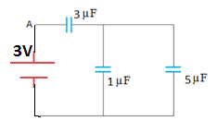

IV. What is the voltage and current in each of the resistances in the circuit below?

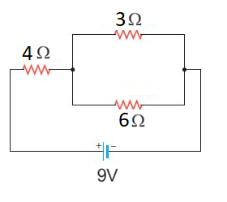

V. Combine all the resistances into a single one, for the circuit shown:

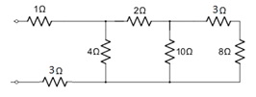

math167

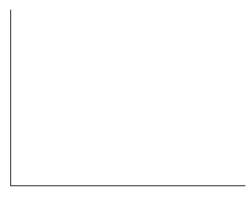

Time constant = τ = *RC*

1. Above equation gives the charge on a capacitor as a   
function of time during charging. Sketch the charge, q   
as a function of time for the above charging of a   
capacitor (C) through a resistor (R), inside the box.

2. If the capacitance is 1.5 F and the resistance is 2.0 ohm, calculate the RC time constant.

3. If the voltage used to charge the above capacitor is 3.0 volt, calculate the charge when the capacitor is fully charged?

4. Calculate the stored energy when the capacitor is fully charged?

5. Calculate the amount of charge in the capacitor after 12 seconds of charging.

VII. Four point charges lie in a Cartesian coordinate system as follows:   
+2.5nC at (0, 0), –4.5nC at (6 m, 0), 3.5nC at (0, 11 m), and – 5.5nC at (0, 8 m). Find the net elec­tric potential at (6 m, 8 m) in volt. Coulomb constant = k = 9 x 109 (SI), n = 10-9.

VIII. Kirchhoff’s Rules. [no need to solve the equations]

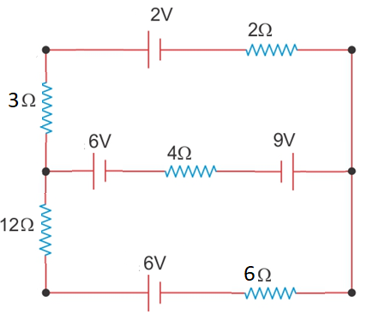

Assign the unknown currents the circuit.

1. Write down the junction rule equation using the assigned currents.

2. Identify the low and high potentials for the resistors and batteries.

3. Write down the potential differences across the resistors in terms of the assigned currents and resistances.

4. Write down the loop rule equation, for the top loop, and simplify.

5. Write down the loop rule equation, for the bottom loop, and simplify.